Template literal: **backtick**

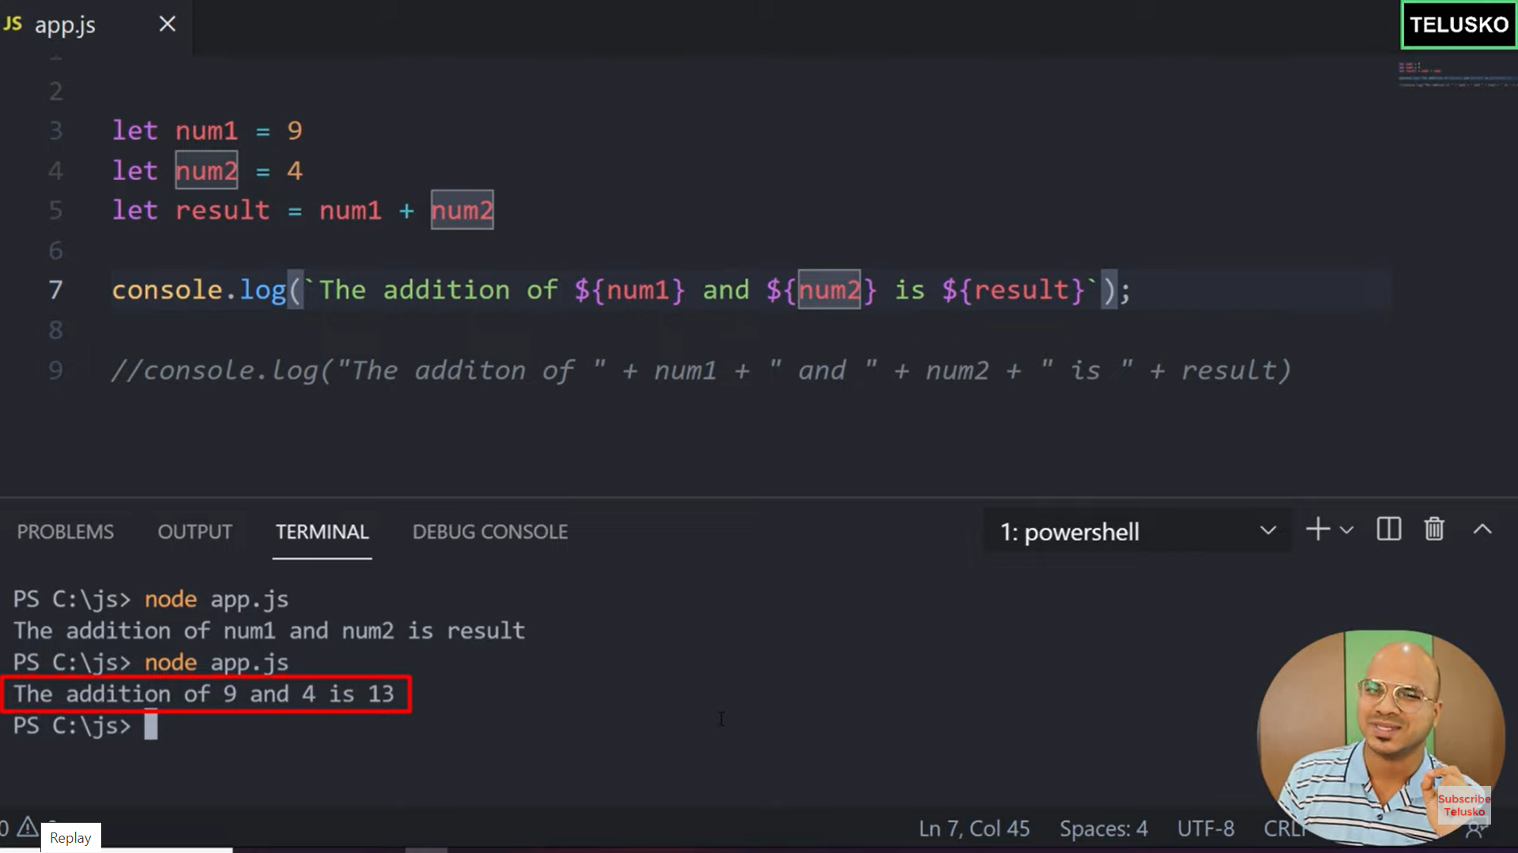

Console.log(`The addition of ${num1} and ${num2} is ${result}` )

Console.log(`My name is

Soumya Penuguvvi`)

**Declaration of Object:** let objName = {}

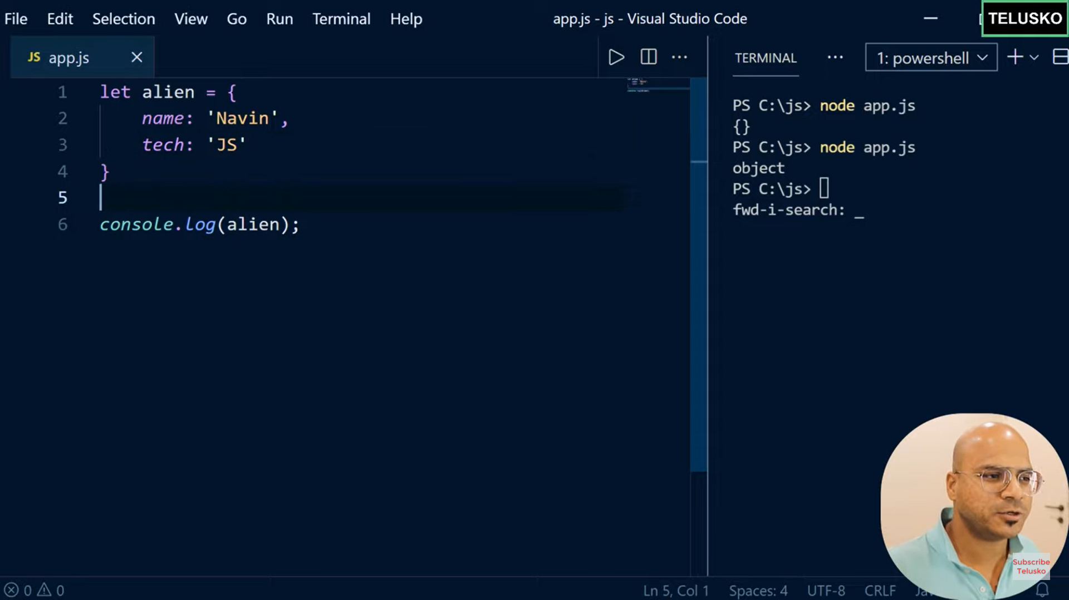

**Fetch value of a property**: . ( Dot operator)

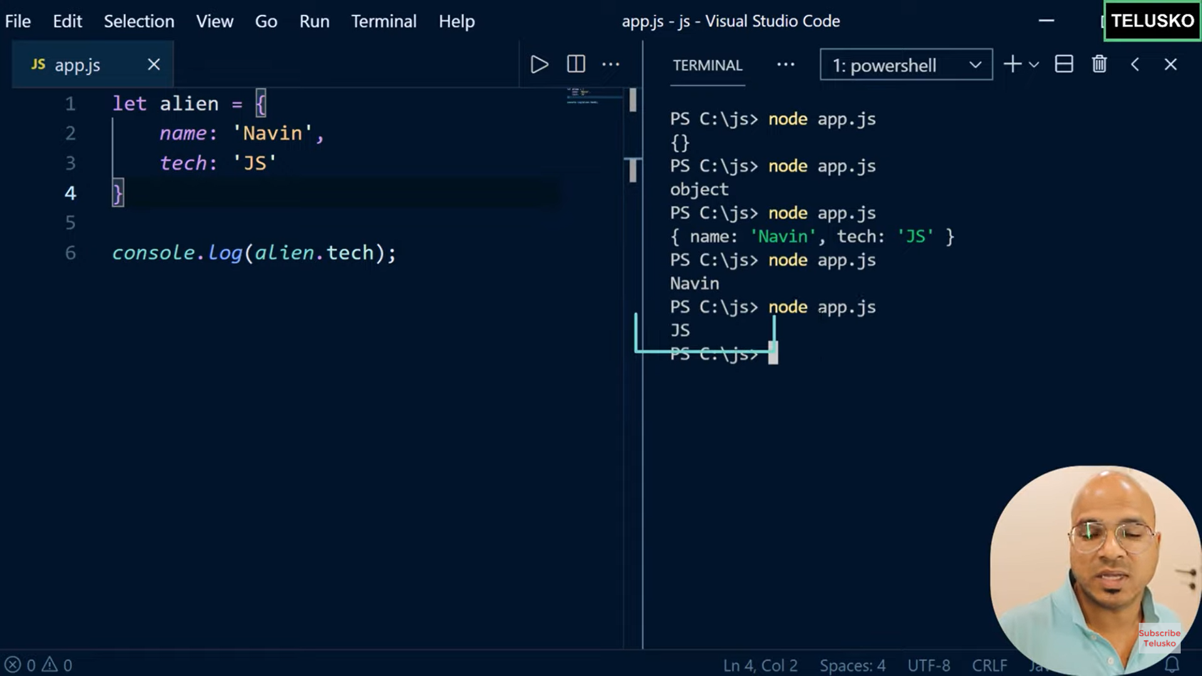

2. Square Braket [‘key’]:

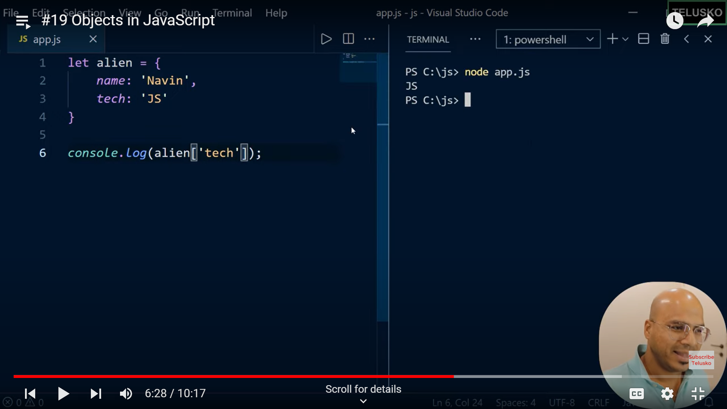

Object Inside Object:

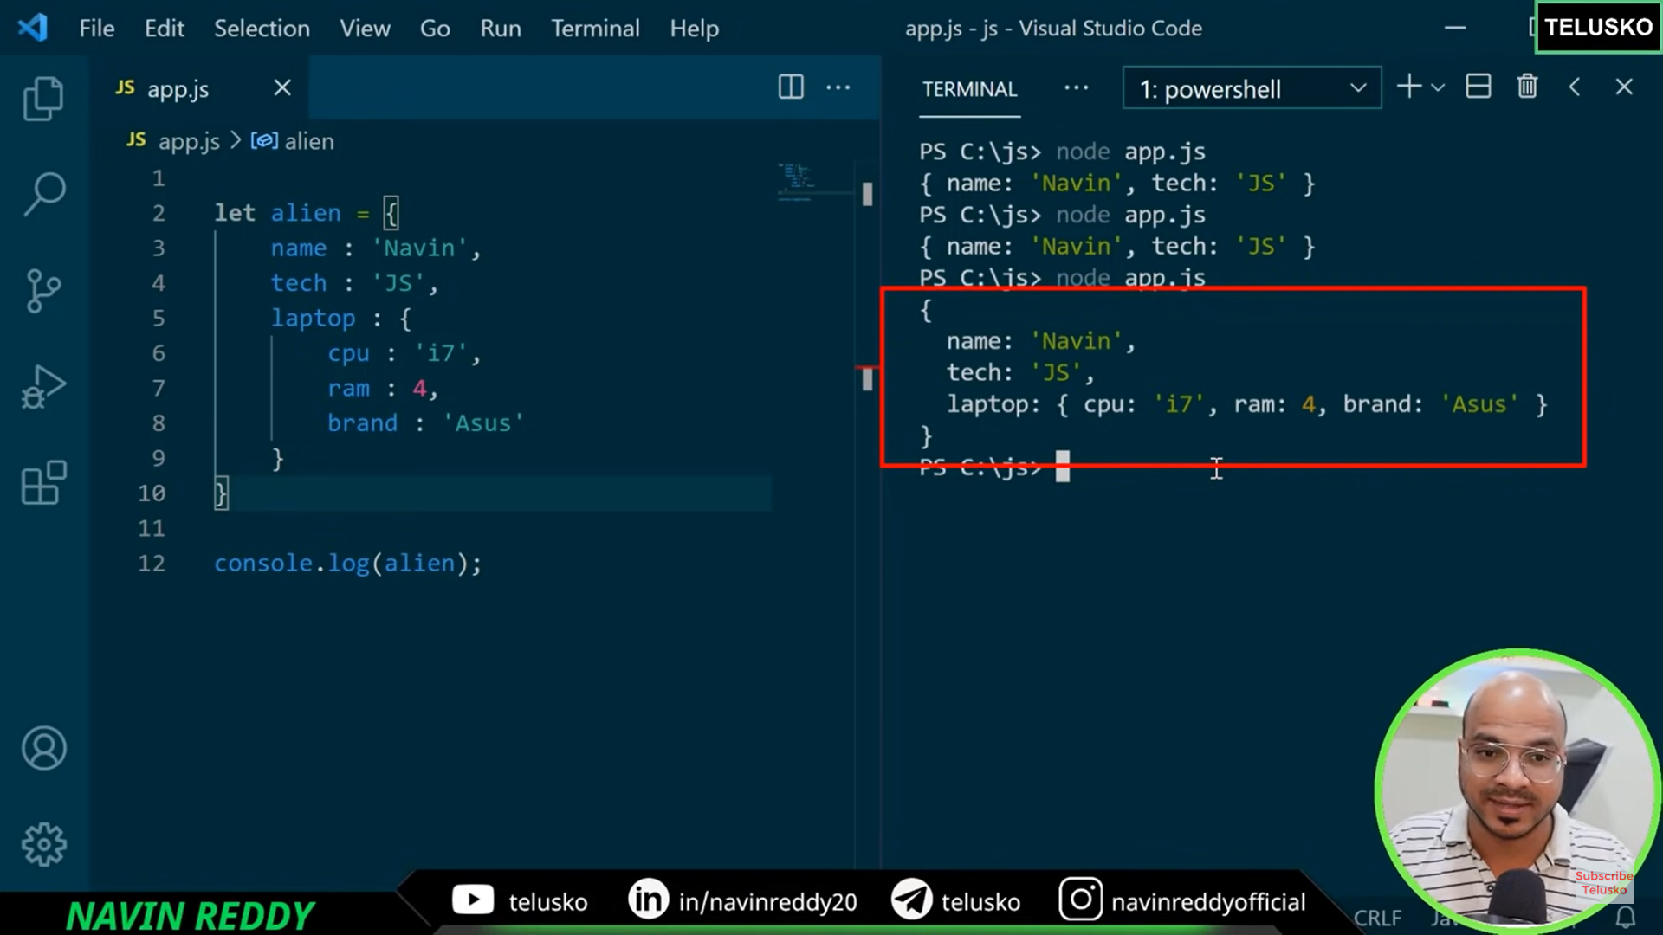

How to print a specific property of an object which itself is in other object?

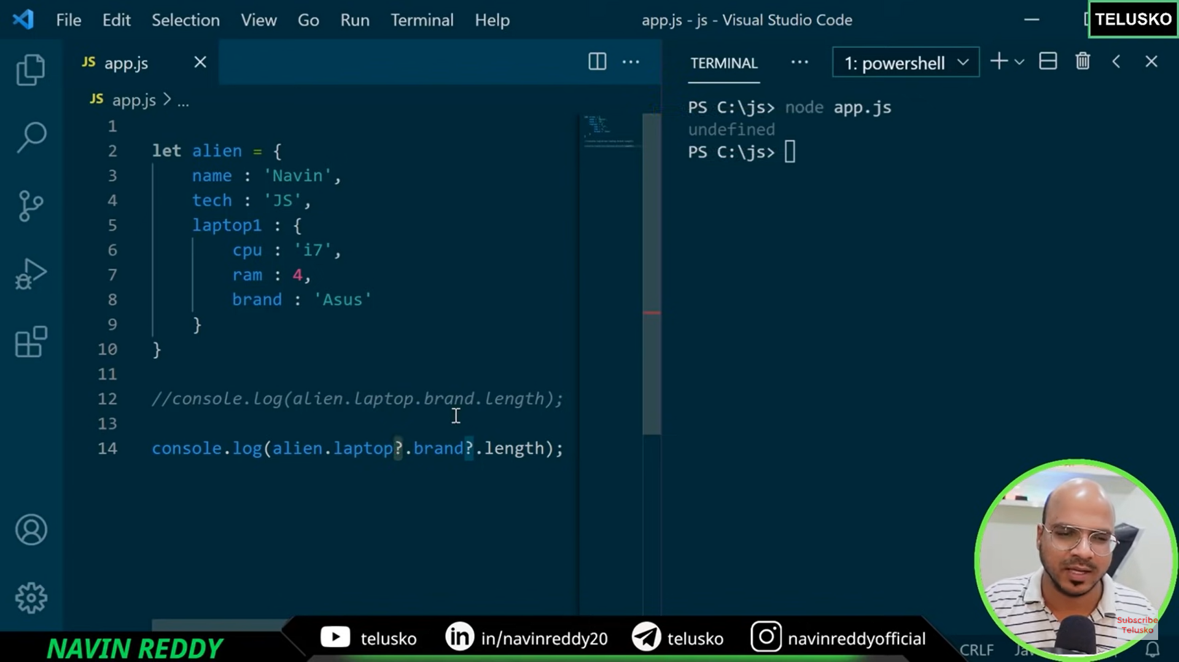

? -🡪 is used to know if particular property is present in an object

Note: We can add an object as a property for an object

**Delete Property From Object**: Delete alien.laptop

**For In loop to print Object Properties:**

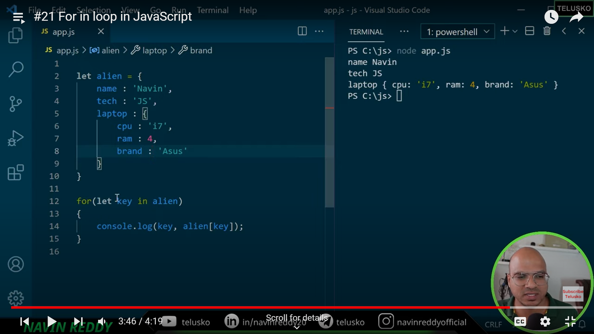

**Function is an object type**

**Function Expression:**

let add = function (num1, num2){

return num1+num2;

}

let result =add(5,6)

console.log(result)

We can have default values for parameters

Add(num1,num2,num3=1){

S

}

Add (5,6) ---🡪 Here defauly value is passed through function. If third argument is also passed into function default value is ignored.

**Arrow Function**:

1. It is a shorthand to declare a function
2. Syntax: let variable = ()=>{}
3. If you have only one statement in an arrow function, no need to have curly braces and return key word

**This**: this keyword refers to the current object

**Constructor Function**: Used to create more objects with same blueprint

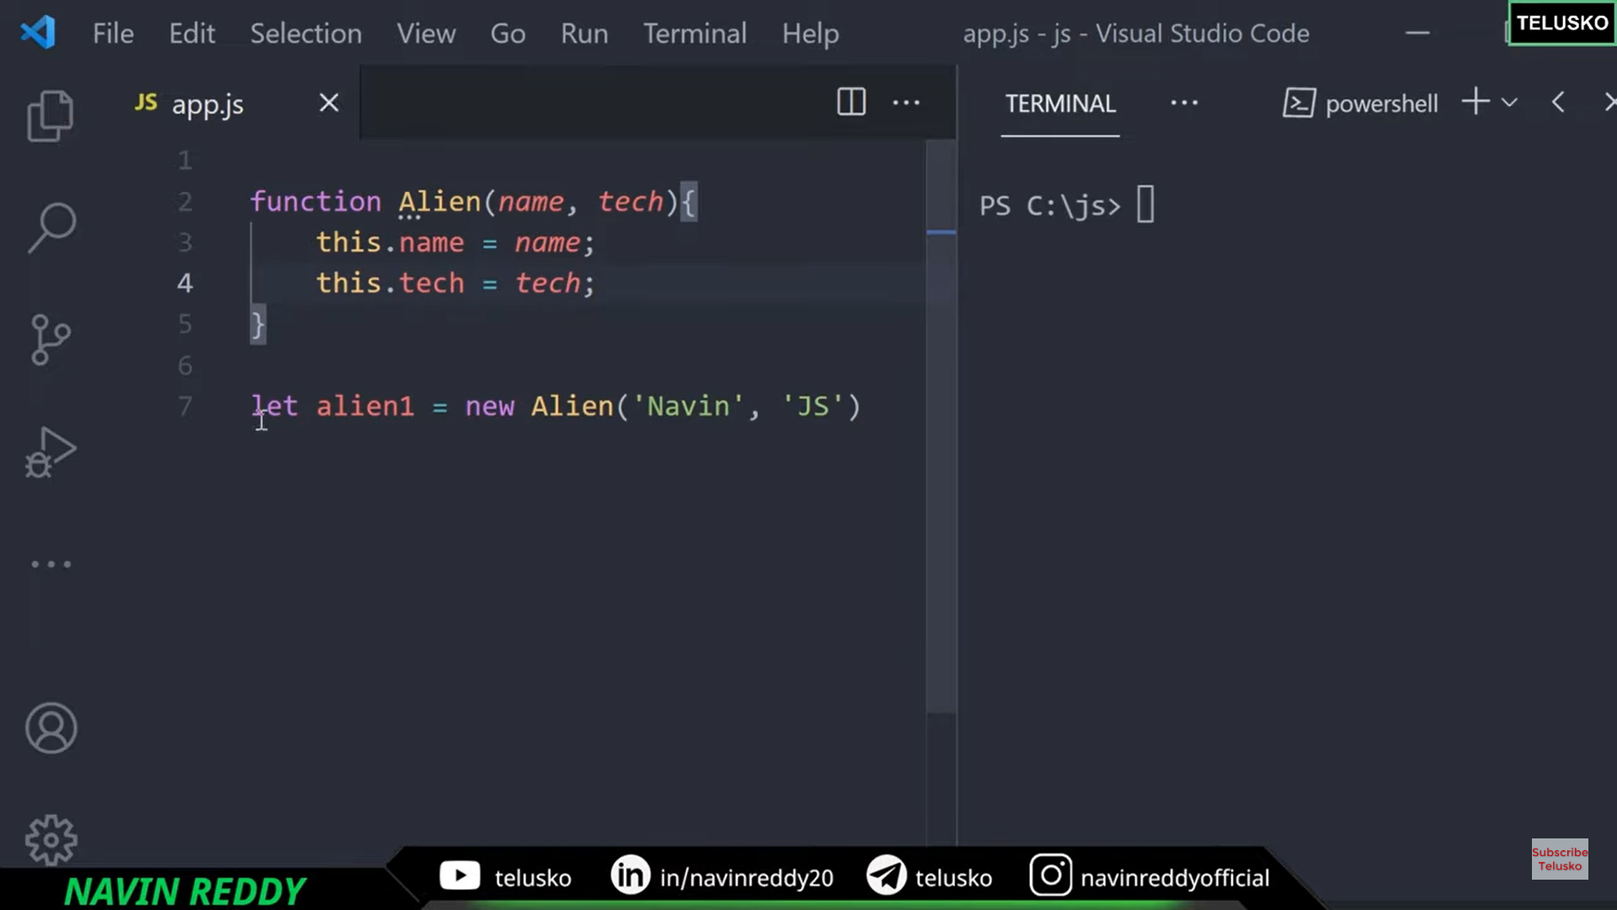

Push is used to push values to the end of Array

Pop will remove element from the end of Array

Shift will remove element from the first Array

Unshift will add element to the start of Array

Array concept is same as stack which follows LIFO

Splice deletes elements from middle of an array

Splice(2,3) – This will remove elements from index 2 and 3 numbers from index 2

Splice(2,2, 11, 15) - This will remove elements from index 2 and 2 numbers from index 2 And add 11 and 15 to the array in the place of the removed elements

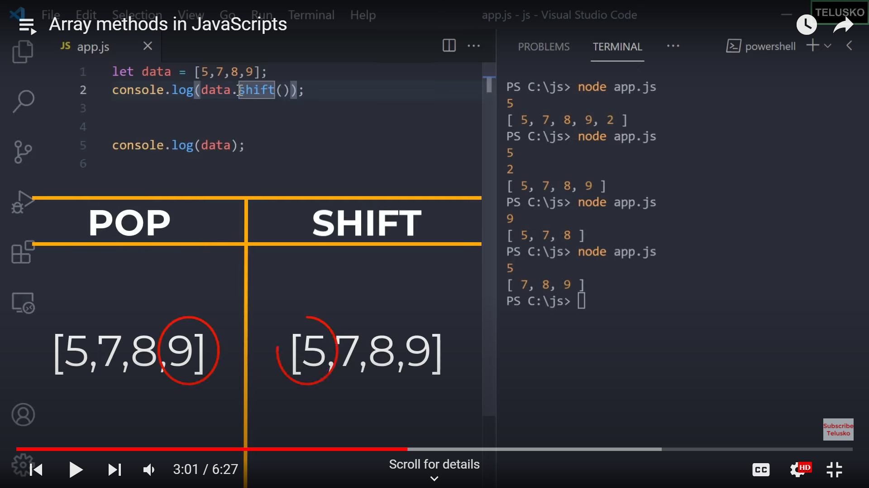

We use for of loop to print elements in the array

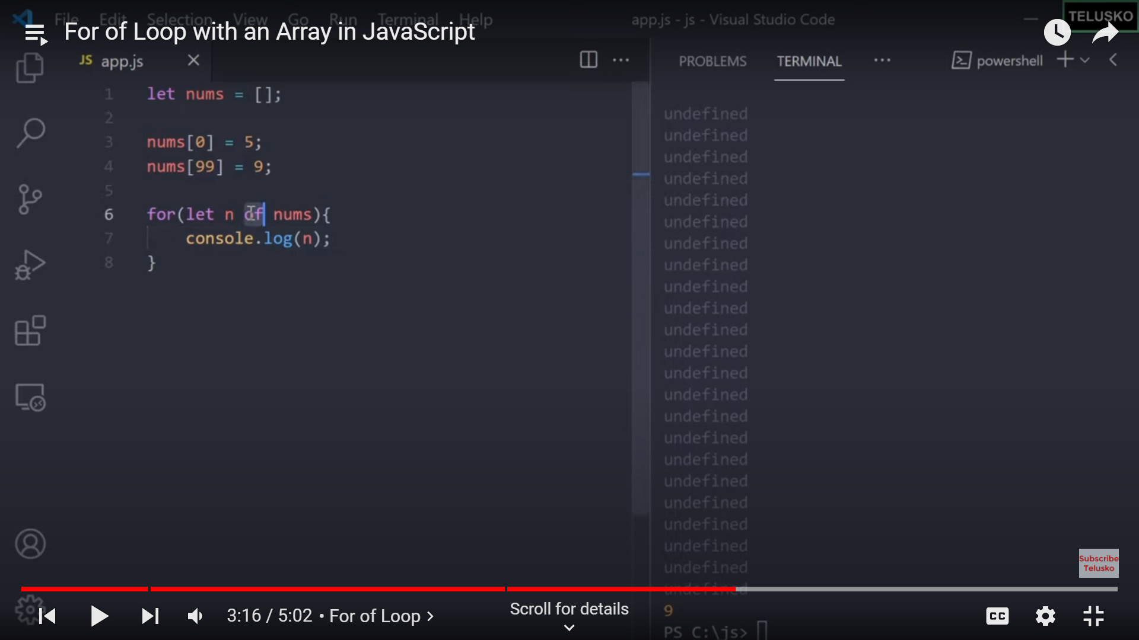

We can use for in loop as well but it is not a good practice

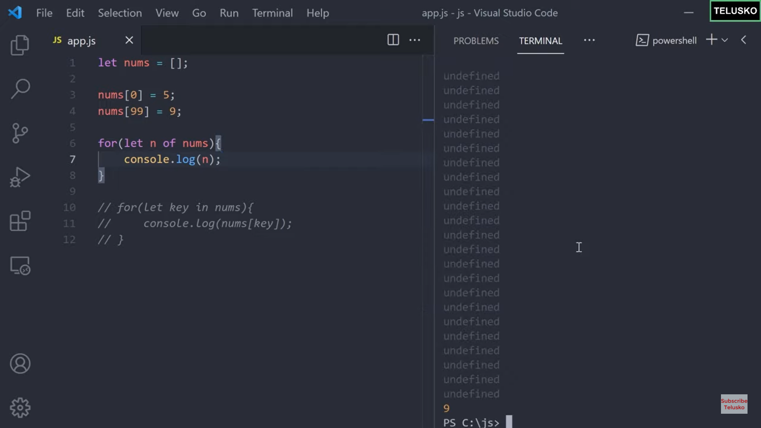

Array Destructuring:

We can assign different elements of array individually to different variables



Swapping of 2 numbers

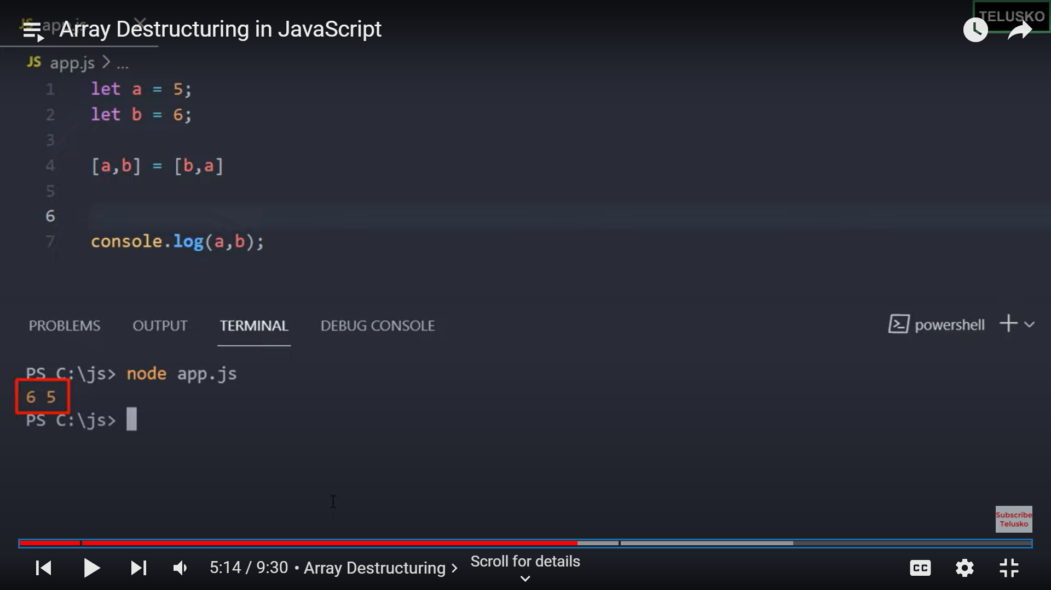

We can create an array of strings by using split

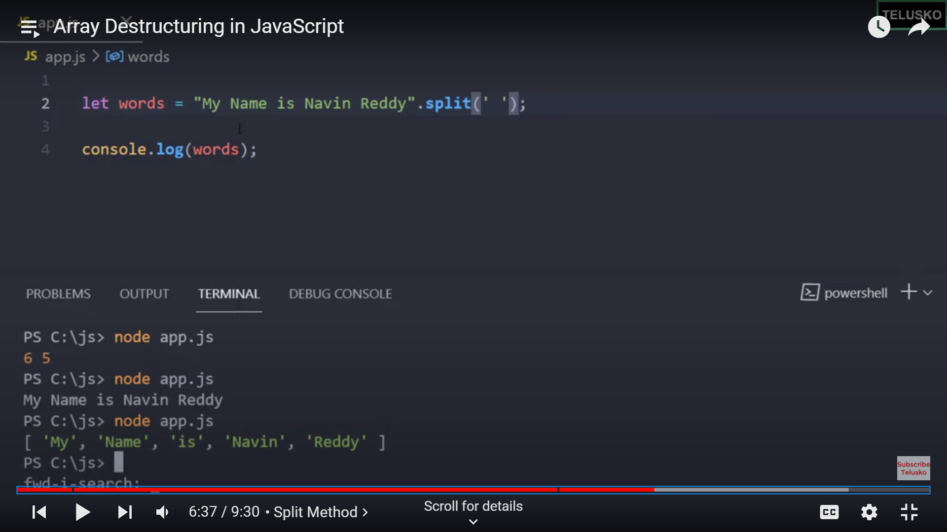

We use 3 dots (…) to club rest of the elements in array while destructuring. The process of destructuring is same as numbers

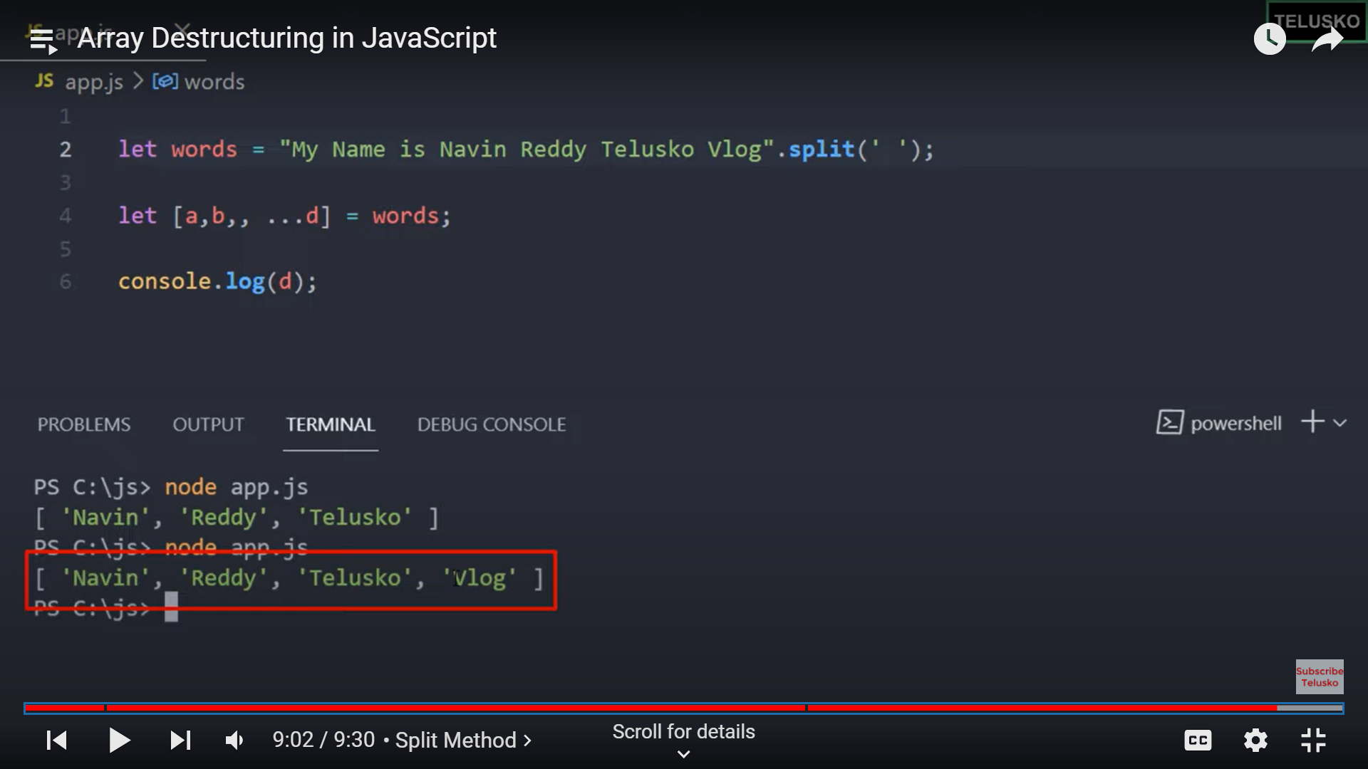

We can get individual elements of an array by using foreach function

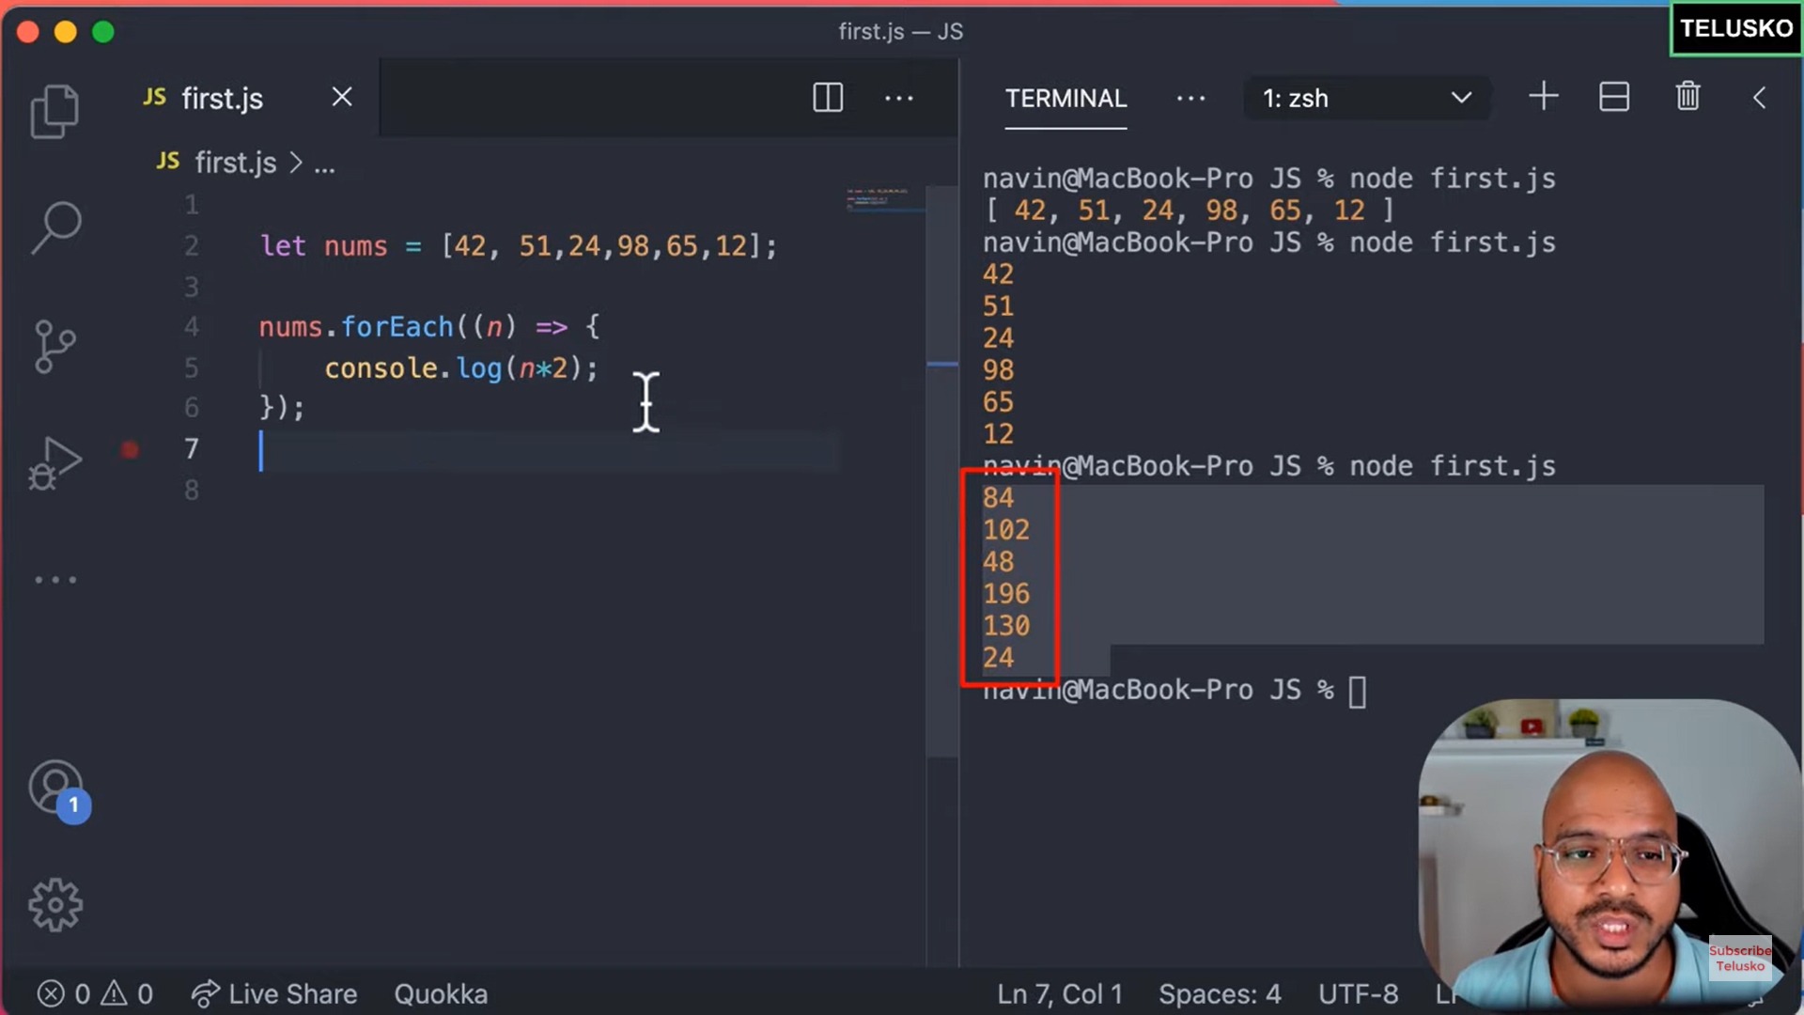

Call back function is a function which returns a new value every time it is called.

We can filter the elements that we pass into a call back function by using filter method which works on a condition (which is equivalent to if)

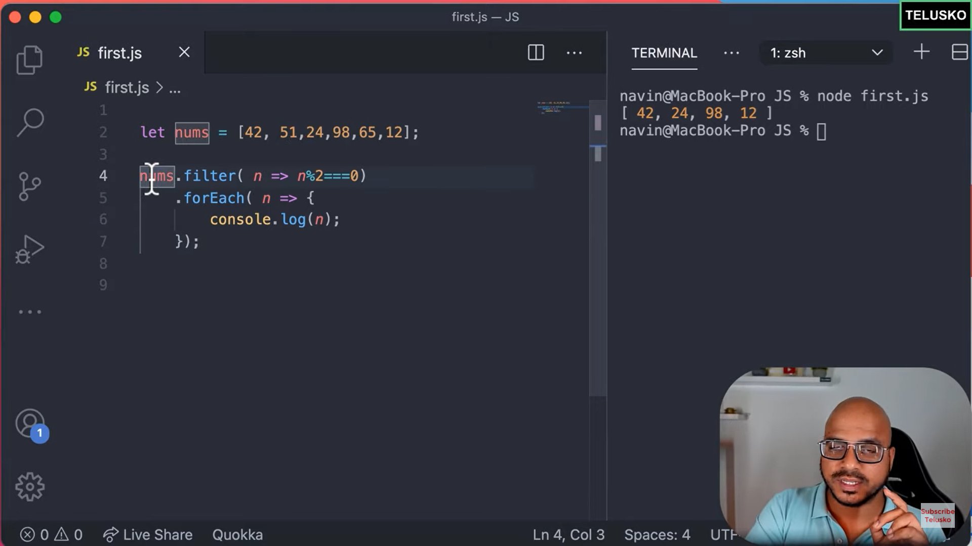

If we need to perform any action or complex operations on elements that are filtered we can use map method



We can replace for each with reduce method

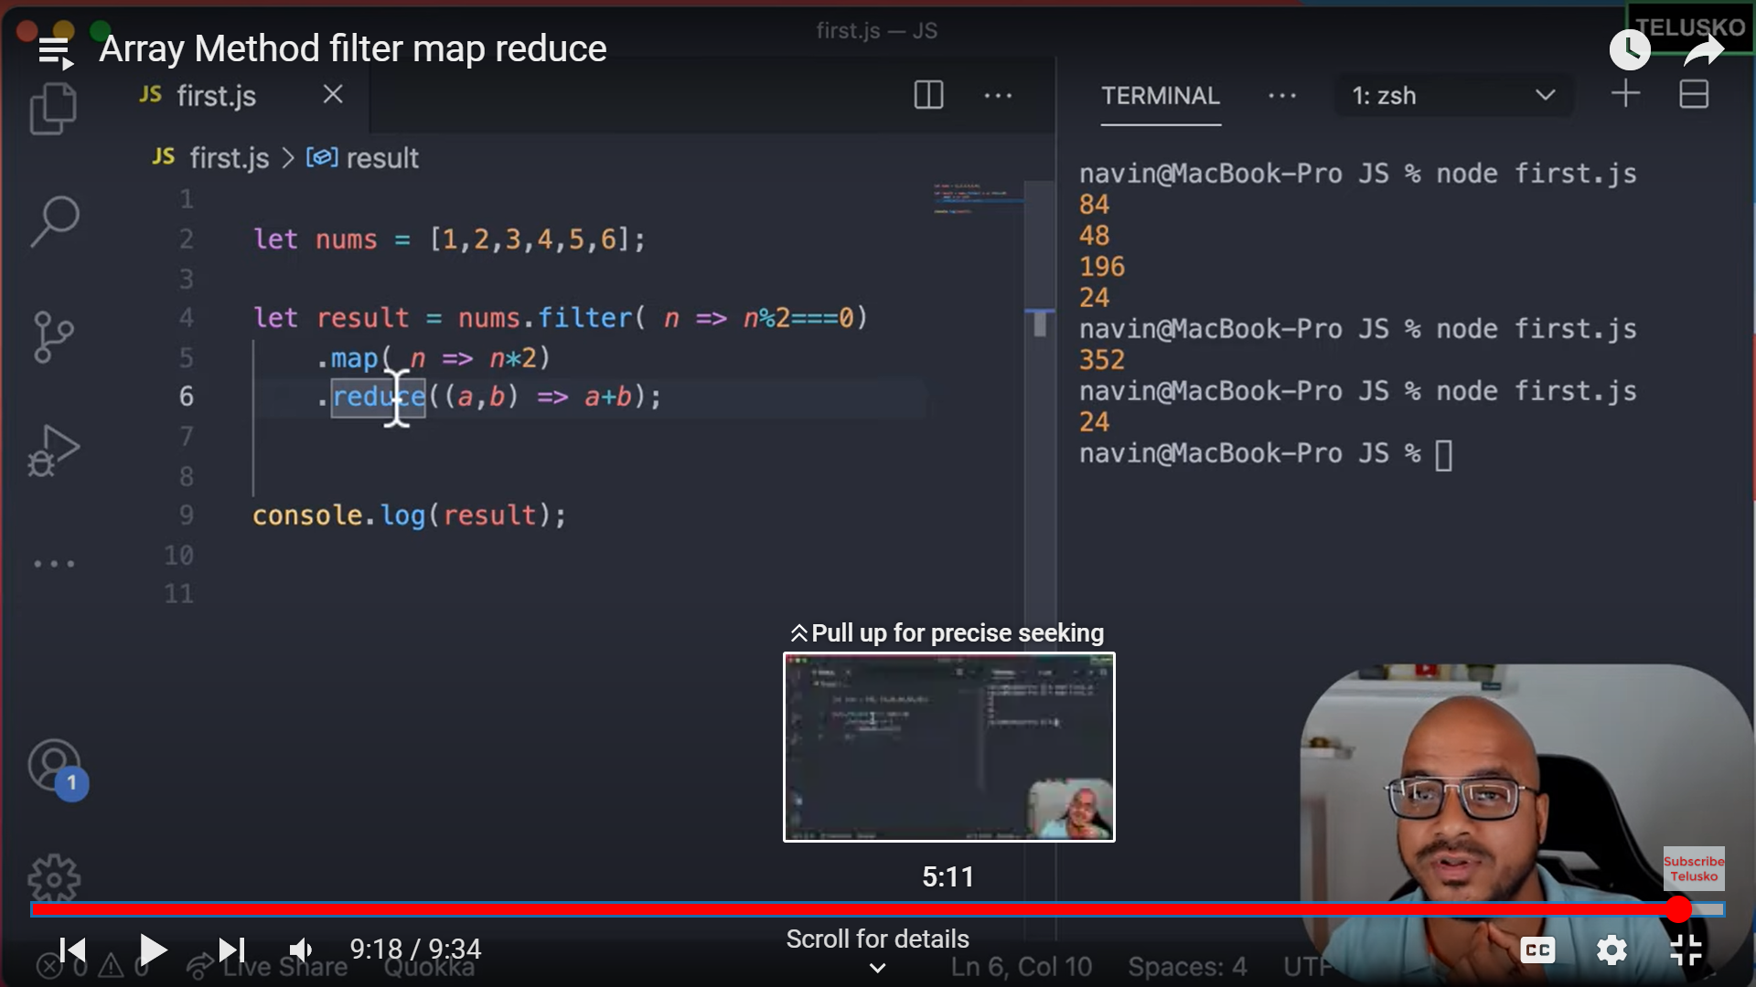

Questions on Fetch API

Questions on Promises

